Extended Abstract (Short/Poster Presentation) for EcoDesign 2005

Yasushi Umeda (Osaka University) and Kazuhiro Aoyama (The University of Tokyo)
umeda@mech.eng.osaka-u.ac.jp, aoyama@naoe.t.u-tokyo.ac.jp

The EcoDesign 2005: "4th International Symposium on Environmentally Conscious Design and Inverse Manufacturing" will be held in Tokyo (Hitotsubashi Memorial Hall, National Center of Sciences Building) in December 12-14, 2005 (Fig.1). All individuals who wish to present technical papers should submit extended abstracts by email (ecodesign2005@ecodenet.com) before March 31, 2005. The filled-out Abstract Submission Form should be attached to your abstract.
40 mm
The technical session consists of full presentations, short presentations, and poster presentations.
- Full presentation style: 25 min for oral presentation (incl. discussions)
2 pages for an Extended Abstract, 4 pages to 8 pages for a Manuscript
- Short presentation style: 15 min for oral presentation (incl. discussions)
1 page for an Extended Abstract, 2 pages for a Manuscript
- Poster presentation style: Presenting at Poster Session
1 page for an Extended Abstract, 2 pages to 4 pages for a Manuscript

Each extended abstract is reviewed by the international EcoDesign 2005 program committee and be judged as accepted / rejected according to the following criteria, in order to increase quality of the symposium. This review process does not imply that EcoDesign 2005 selects only academic papers. Papers describing industrial, business, and social experiences are also welcome.
- Relevance to the scope of EcoDesign 2005
- Originarity of the proposed contents
- Significance of the proposed results to the scope of EcoDesign 2005

Notification with some reviewers’ comments will be sent in late June, 2005 by e-mail. Any inquiry for the submission, please feel free to contact the secretariat by e-mail at your earliest convenience.
Proceedings will be published from IEEE Computer Society Press. Manuscripts are limited to the following pages (Letter or A4 size paper), including all figures, tables, and references and should be submitted before August 31, 2005. Detailed information will be sent with notification of acceptance.
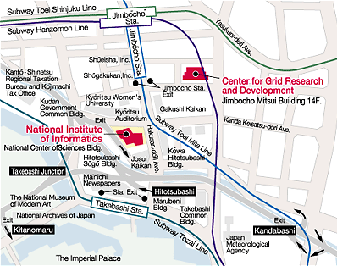
Fig.1 Hitotsubashi Memorial Hall
National Center of Sciences Building
http://www.nii.ac.jp/help-e.html

The completed manuscripts will be published by means electronic proceedings (PDF files in CD-ROM). The used fonts and format of submitted manuscripts will be checked to make electronic proceedings. For updated information, please check EcoDesign 2005 web site.
http://www.ecodenet.com/ed2005/

Further information and any inquiry please contact to:

EcoDesign 2005 Secretariat:
ecodesign2005@ecodenet.com
NPO EcoDesign Promotion Network
Tel: +81-3-5841-1171

